AP Comparative
Seim Name ________________________________________

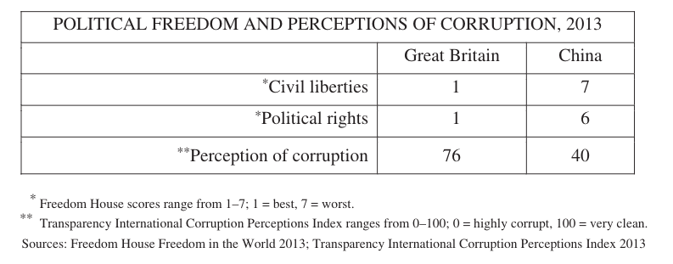
Corruption is a challenge faced by regimes that have different levels of civil liberties and political rights.
- Based on the information in the table, describe the difference between the levels of perceived corruption in China and Great Britain.
- Based on the information in the table, describe the difference between the levels of political freedom in China and Great Britain.
- Explain how political freedoms affect the ability of democracies such as Great Britain to fight corruption.
- Describe one way that China is attempting to limit corruption.
- Describe one shared political reason why China and Great Britain seek to limit corruption. Describe one shared economic reason why China and Great Britain seek to limit corruption.

